Healthy Halloween Hustle Sponsor Registration Form
5k Virtual Fun Run/Walk/Tread
October 1, 2018 – October 31, 2018

___“Yes” – I would like to support the Xenia Community Schools Foundations Classroom Grants Program for Xenia Community Schools. (Pick sponsorship level below)
__ Individual - $50.00 - Name on T-shirts
__ Corporate - $100.00 - Name of business on T-shirts, recognition on website, sponsor provided promotional items in shirt bags
__Health Hero Sponsorship - $250.00 - Name of business and one-color small logo on T-shirts, sponsor provided promotional materials in shirt bags, recognition on website and Facebook
__Health Champion Sponsorship - $500.00 - Name of business and one-color large logo on T-shirts, sponsor provided promotional materials in shirt bags, recognition on website and Facebook
Sponsorships are due by September 7, 2018.
Name ______________________________________________
Company Name ______________________________________
Address_____________________________________________
_____________________________________________
Phone______________________________________________
Email_______________________________________________
Please return the form and check (payable to the Xenia Community Schools Foundation) to:
C/o The Xenia Area Chamber of Commerce
334 W. Market Street
Xenia, Ohio 45385
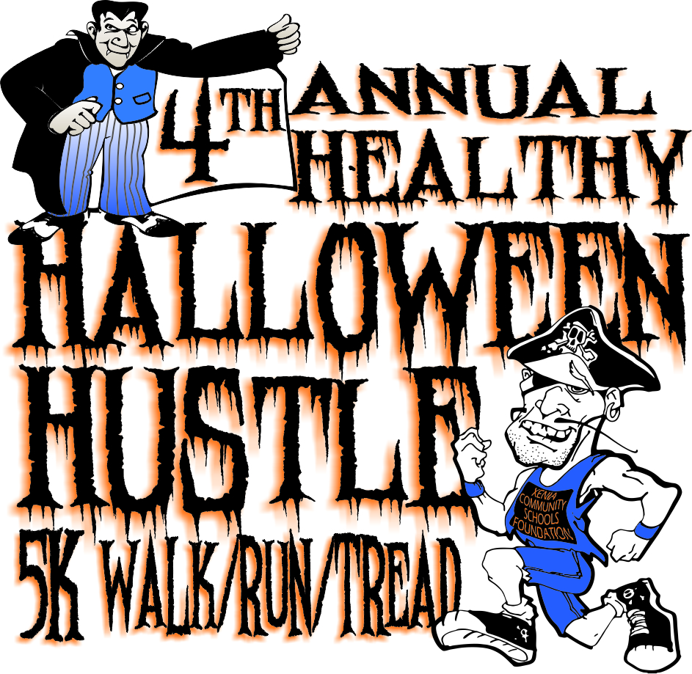
Questions? Call (937)-620-0790

