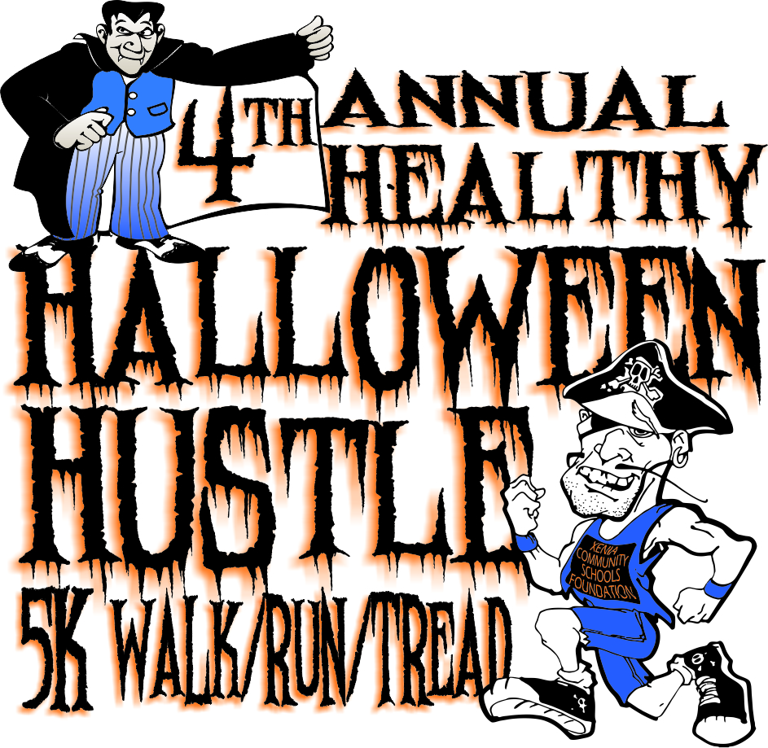
Registration Form
5k Virtual Fun Run/Walk/Tread
Proceeds benefit the Xenia Community Schools Foundation Classroom Grants Program
October 1, 2018 – October 31, 2018

This is now a virtual event! Registrants will set a goal of completing one, two or three 5k walk/run/treads during October. Upon reporting back completion of their commitment (on their own or with friends at a time and place of their choice), registrants will be awarded a participation medal in bronze, silver or gold based on the goal they achieved.
All registrants will receive an event shirt to wear during the entire month of October in support of the run/walk. Those who simply want to support the Healthy Halloween Hustle, can just register and receive a shirt.
Name: ________________________________________ School: __________________________________
Address: ______________________________________ Phone: __________________________________
______________________________________ Email: ___________________________________
___ Adult ($15.00) - Shirt Size __ SM __ Med __ L __ XL __ XXL
___Student K - 12 ($10.00) Shirt Size__ SM Youth __Med Youth __Large Youth __XL Youth (Check an Adult Size above if appropriate)
Personal Goal: ___One 5k (bronze) ___Two 5k (silver) ___ Three 5k (gold) ___ Registration only
Registration Deadline to be guaranteed a shirt: September 14, 2018. A limited number of shirts will be available for registrations after that date.
Release for________________________________

Release: In consideration of the acceptance of my entry, I, for myself, my executors, administrators, and assignees, do hereby release and discharge the Xenia Community Schools Foundation and its/their officers, directors, trustees, employees, agents, and all other sponsors and individuals assisting in the presentation of the race for all claims of damages, demands and actions whatsoever in any manner arising or growing out of my participation in said athletic event. I attest and verify that I have full knowledge of the risk involved in this event and I am physically fit and sufficiently trained to participate in this event.
_________________________________________________________________
Participant or Legal Parent or Guardian (if participant is a minor) / Date

Option 1: Online Registration@ xcsfoundation.com (Use PayPal)
Option 2: Payment: Check, Money Order or Cash in a Sealed Envelope – The registration form and payment can be left in the Office at each Xenia Community School Building.

